**AUTOMATED TRACKING MACHINE**

**BY**

**SAMAILA JACOB**

**ST/CS/ND/19/256**

**A SEMINAR PRESENTED TO THE DEPARTMENT OF COMPUTER SCIENCE,**

**SCHOOL OF SCIENCE AND TECHNOLOGY, FEDERAL POLYTECHNIC MUBI,**

**ADAMAWA STATE, NIGERIA**

**NOVEMBER, 2021**

*ABSTRACT*

*And Figures Object tracking system play important roles in tracking objects and overcoming problems such as safety, security and other location-related applications. Problems arise from the difficulties in creating a well-defined and understandable description of racking systems.*

**Introduction**

According to Thomas, Robert. Travvis, Dawna (March, 2009) describing such processes results in fragmental representation that most of the time leads to difficulties creating documentation? Additionally, once learned by assigned personal, repeated task result in them continuing on autopilot in a way that often degrades their effectiveness. This paper proposes the automated of tracking machine in terms of a new diagrammatic methodology to produce engineering-like schemata. The result diagrams can be used in documentation, explanation, communication and control.

**Description of tracking machine**

Tracking machine is a fast vehicle which, with the aid of global assistants system or GPS help in finding out the location of person or object.

**The major constituents of the automated machine tracking are:**

According to Robert, William, (September, 2001)

1. GPS tracking unit the device fits into the vehicle and captures he GPS location information apart from other vehicle information can at regular intervals to a central server. Other vehicle information can include fuel amount, engine temperature, altitude, reverse geocoding, door open/close, tire pressure, cut off fuel, turn off ignition, turn on headlight, turn on taillight, battery status, GSM area code/close code decoded, number of GPS satellites in view, glass open/close, fuel amount, emergency button status, cumulative idling, computed odometer, engine RPM, throttle position, GPRS status and a lot more. Capability of these devices actually decide the final capability of the whole tracking system; most vehicle tracking systems, in addition to providing the vehicle’s location data, feature a wide range of communication ports that can be used to integrate other onboard systems, allowing to check their status and control or automate their operation.
2. GPS tracking server: the tracking server has three responsibilities receiving data from the GPS tracking unit, securely storing it, and serving this information on demand to the user.
3. User interface: the UI determines how one will be able to access information, view vehicle data, and elicit important details from it.

**Advantages and disadvantages of automated tracking machine.**

According to Stephen, Lengfun. (December, 2020) The advancement in GPS tracking has helped to dramatically reduce car theft and increase productivity. From keeping family members safe to tracking employees and recovering valuable assets, vehicle trackers of using a tracking device for your vehicle, but there are some features that may inconvenience the owner. Here we’ll run through all the advantages and disadvantages of vehicle trackers, including how they can improve your life and the problems associated with them so you can be fully informed if and when you decide to invest.

**Advantages**

According to Stephen, Lengfun. (December, 2020) As well as allowing you to track the whereabouts of your vehicle, telematics systems gather vast amounts of information on speed, the working order of your car and engine usage. This information can be used to improve driving habits, lower fuel expenses and keep whoever is behind the wheel safe.

1. Increased Security: tracking can help vehicle owners protect one of their largest assets from thieves. Depending on the device you choose, it can use sensors to set off an alarm to deter theft and initiate safe zones. Safe zones, otherwise known as a geo-fence, is a virtual fence around a specific location, you will be sent an instant message when the tracker enters or leaves the virtual border, acting as an early warning system for theft.
2. Theft Recovery: real-time tracking allow a stolen car to be located within minutes from a smartphone or laptop, so should the worst happen you can contact the police and recover your vehicle quickly and efficiently.
3. Personal Safety: not many people are aware that some tracckers can help to reduce car accidents and increase the safety of the driver. The owner of the car can set speed limits and alerts for risky driving to prevent employees or family members from driving your vehicle irresponsibly.
4. Increase Productivity: for management purpose, the benefits of GPS tracking are invaluable! Not only can you use it to increase the productivity of your employees, but you can provide your customers with the exact location of their item being delivered at any point during the shipping process. A GPS tracker helps you monitor the location of your fleet and your employees which helps to avoid unauthorized stops and breaks and track their total mileage and delivery times.
5. Save Money: whilst buying the tracking device itself can be pretty expensive, you will save money in other aspects. Such as receiving discounts on insurance policies simply be having a tracker installed, and using driving data to save money on fuel.

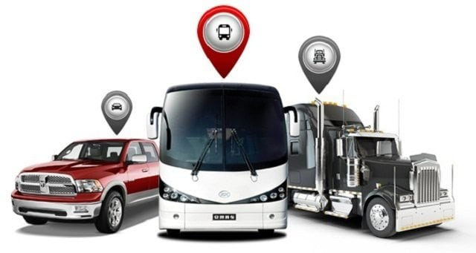

**Figure 1.**

**Disadvantages**

According to Stephen, Lengfun. (December, 2020)While installing a tracker into your vehicle has its advantages, there are some problems associated with them such as signal jamming, power dependency, privacy and cost.

1. Many people consider tracking vehicle to be an invasion of privacy, which could be an issue if you’re planning to use the device for business purposes. Luckily, when it comes to vehicle tracking in industry, there are laws in place to protect employee’s personal data. As an employee, you must always get your employees permission before installing a tracking device to their vehicle and ensure they know exactly how it works. Make sure you check out our blog posts on vehicle Tracking Laws for Business Owners and for Employees to you know exactly what’s allowed and what isn’t.
2. Price: for a good vehicle tracker with all the most cons, you can expect to pay quite a lot of money, but, there are trackers out there that range in price, and some are very reasonable. Do your research to make sure you’re buying a tracker that matches your needs to avoid overspending.
3. Signal Jamming: GPS trackers which can stop you from locating your vehicle. These are becoming increasingly popular amongst tech-savvy thieves. Unfortunately, the only way to stop signal jamming is to report the problem.
4. Power Sourcing: both battery-powered trackers need to be kept charged at all times in other for them to work, which could become tedious. The charging time of a device varies significantly between models and they are considered easy to install. Hardwired trackers on the other hand use power from your car’s battery, so there’s no need to re-charge. However, if they’re not installed properly this can lead to its depletion, and they are more difficult to install.

**Architectural view**

According to Robert, William, (September, 2001)

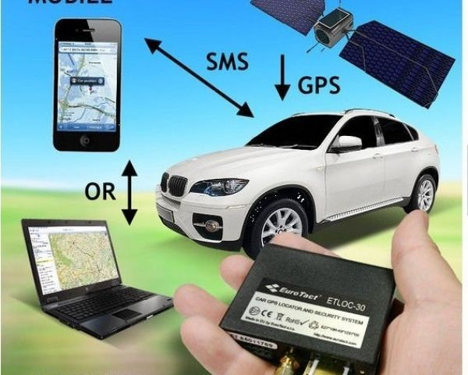

**Figure 2.**

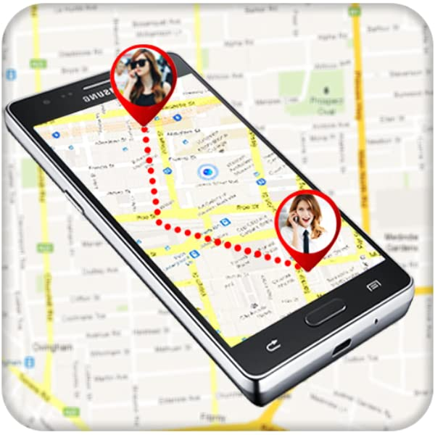

**Figure 3**

**Conclusion**

Travvis, Dawna (March, 2009) concluded that several types for vehicle tracking devices exist. Typically they are classified as “passive” and “active”, “passive” devices store GPS location, speed, heading and sometimes a trigger event such as key on/off, door open/closed. Once the vehicle returns to a predetermined point, the device is removed and the data downloaded to a computer for evaluation. Passive systems include auto download type that transfer data via wireless download. “Active” devices also collect the same information but usually transmit the data in near-real-time via cellular or satellite networks to a computer or data center for evaluation.

**Reference**

Thomas, Robert. M., Travvis, D. (March, 2009) Introduction to Local Area  
 Network. Used for tracking machine *Vaskevitch, David UK*

Robert, William, (September, 2001) comparative study on 2-tier and 3-tier  
 tools; Architecture *USA CSI communications*.

Stephen, Lengfun. (December, 2020) tracking system advantage and  
 disadvantage. *Bangladish India,*

URL

[*http://www.education-onlineearch.com*](http://www.education-onlineearch.com)

[*http://orca.st.usm.edu/~seyfarth/network_pgm/net-6-3.html*](http://orca.st.usm.edu/~seyfarth/network_pgm/net-6-3.html)

[*http://www.se.cuhk.edu.hk*](http://www.se.cuhk.edu.hk)

*http://ww.gerrardconsulting.com/GUI/TestGui.htm*